- INTRODUCTION
The event is for three-boat teams and will be sailed in Fireflies provided by the organising authority (UCLSC). It will be held at Welsh Harp Sailing Club, Birchen Grove, London NW9 8SA. Each boat shall be sailed by two people.

- ORGANISING AUTHORITY
The organising authority is Students’ Union UCL Sailing Club.

- RULES
  - The event will be governed by the rules as defined in the Racing Rules of Sailing (RRS) including Appendix D, Team Racing Rules.
  - Races will be umpired.
  - The UK Team Racing Association (UKTRA) Standard Team Racing Sailing Instructions will apply.
These change some rules in the Racing Rules of Sailing (RRS); they are available on the UKTRA website (www.teamracing.org).
3.4 In accordance with RRS 70.5(a) the right of appeal will be denied.

- ENTRIES
  - Teams may apply for entry through the entry form posted on the BUSA events calendar along with the NOR
  - Entry of up to 12 teams is permitted.
  - Teams not qualifying for entry, will be arranged and ordered on the reserves list.
  - The entry fee will be £325 per team which includes breakfast and lunch on both Saturday and Sunday
  - The closing date for receipt of entries is Friday 6th November 2026.
  - Each team will be liable for the cost of damage to boats, equipment and property up to a maximum of £300 per incident. A deposit for this amount will be required at registration in the form of cash/cheque and before a team may sail. If the organising authority estimates that the total damage attributable to the team exceeds the deposit, the team will be required to deposit a further £300 in order to continue sailing. Damage attributed to competitors generally or to an unidentified team will be attributed equally between all teams. A team may apply to the Organising Authority after consultation with the umpires, in order to determine their responsibility for any damage.
  - In the event of racing being cancelled due to adverse weather conditions, only damage deposits will be returned.

5. EVENT FORMAT AND SCHEDULE
5.1 The format of the event is detailed in the accompanying Sailing Instructions.
5.3 Registration will take place at Welsh Harp Sailing Club (NW9 8SA) at 8:30am on Saturday 21st November 2026.
5.4 There will be a briefing at Welsh Harp Sailing Club (NW9 8SA) at 9.00am on Sunday 22nd November 2026
5.5 The first warning signal will be at 9.27am on Sunday 22nd November 2026

- BUOYANCY AND CLOTHING
Adequate personal flotation devices and wet / dry suits shall be worn by all competitors at all times when afloat.

- CANCELLATION
7.1 The organising authority may cancel the event, cancel classes and reject or cancel entries in its absolute discretion, subject to RRS 76
7.2 Should the Organising Authority, for any reason other than weather (see 4.6), cancel the event at least 36 hours prior to the scheduled start of race 1 the entry will be refunded less any costs incurred. Should the Organising Authority, for any reason other than weather (see 4.6), cancel the event within 36 hours of the scheduled start of race 1 any refunds will be at the sole discretion of the Organising Authority.
If an entry is cancelled by a competitor, the entry fee will be refunded as follows

Cancellation date | Entry Fee refund
Up to 6th November 2026 12pm (noon) | 100%
Up to 13th November 2026 12pm (noon) | 50%
After 13th November 2026 12pm (noon) | 0%

- RISK STATEMENT, INSURANCE
8.1 Rule 3 of the Racing Rules of Sailing states: “The responsibility for a boat's decision to participate in a race or to continue racing is hers alone”.
Sailing is by its nature an unpredictable sport and therefore inherently involves an element of risk. By taking part in the event, each competitor agrees and acknowledges that:
- They are aware of the inherent element of risk involved in the sport and accept responsibility for the exposure of themselves, their crew and their boat to such inherent risk whilst taking part in the event;
- They are responsible for the safety of themselves, their crew, their boat and their other property whether afloat or ashore;
- They accept responsibility for any injury, damage or loss to the extent caused by their own actions or omissions;
- The provision of a race management team, patrol boats, umpires and other officials and volunteers by the event organiser does not relieve them of their own responsibilities;
- The provision of patrol boat cover is limited to such assistance, particularly in extreme weather conditions, as can be practically provided in the circumstances
- It is their responsibility to familiarise themselves with any risks specific to the host venue or the event drawn to their attention in any rules and information produced for the venue or event and to attend any safety briefing held for the event.
- It is their responsibility to ensure that they are familiar with the type of boat used, and the supplied equipment, and are suitably experienced with its operation.
- It is their responsibility for ensuring all supplied equipment is carried on board.
- They are fit to sail and that they believe the crew and the boat and crew is capable of competing in the anticipated conditions
8.2 When the boats are provided by the competitors, the boat is required to hold adequate insurance and in particular to hold insurance against third party claims in the sum of at least £3,000,000 pounds.

- PRIZES
These will be awarded at the discretion of the organising authority.

Any further inquiries or questions can be taken up with –

President: Emilia Urbaniak (emilia.urbaniak.25@ucl.ac.uk)
Treasurer: Ingrid Yeung (ingrid.yeung.24@ucl.ac.uk)

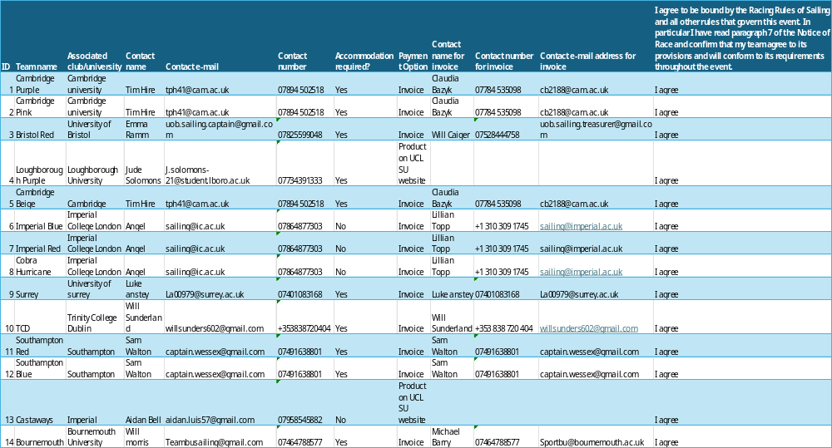
- Entries

